# **Name: Abdurrahman Qureshi**

# **Roll No: 210451**

Practical No: 15

**1) Write a program to conceal email**

**CODE:**

<!DOCTYPE html>  
<html lang="en">  
<head>  
 <meta charset="UTF-8">  
 <title>Title</title>  
 <style>  
 body{  
 font-family: sans-serif;  
 }  
 </style>  
</head>  
<body>  
 <h1 id="og-mail"></h1>  
 <h1 id="new-mail"></h1>  
 <script>  
 let ***myEmail*** = "trevorphilips@gmail.com"  
 let ***ogMail*** = ***document***.getElementById("og-mail")  
 let ***newMail*** = ***document***.getElementById("new-mail")  
  
 ***ogMail***.innerHTML = "Original Email : " + ***myEmail*** let ***splittedMail*** = ***myEmail***.split("@")  
  
 let ***mailP1*** = ***splittedMail***[0]  
 let ***mailP2*** = ***splittedMail***[1]  
  
 let ***mailAvg*** = ***mailP1***.length/2  
  
 ***mailP1*** = ***mailP1***.substring(0,***mailP1***.length-***mailAvg***)  
  
 ***newMail***.innerHTML = "Hidden Mail : " + ***mailP1*** + "....@" + ***mailP2*** </script>  
</body>  
</html>

**OUTPUT:**

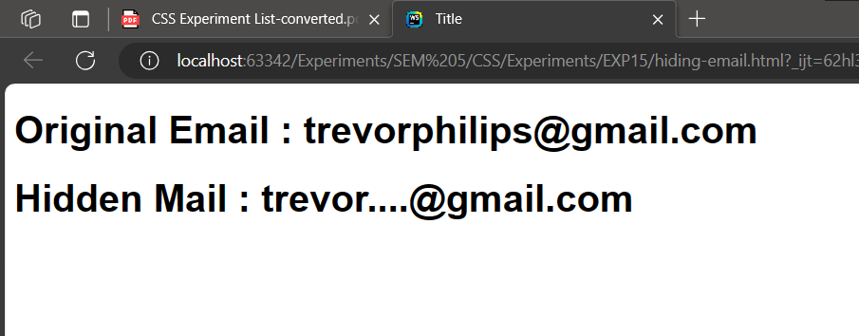

**2) Write a program to hide a phone number**

**CODE:**

**<html lang="en">  
 <head>  
 <meta charset="UTF-8" />  
 <meta name="viewport" content="width=device-width, initial-scale=1.0" />  
 <title>Document</title>  
 </head>  
 <body>  
 <h1 id="ogNum"></h1>  
 <h1 id="newNum"></h1>  
 <script>  
 const *x* = prompt("Enter your number");  
 if (*x*.length !== 10) {  
 alert("invalid phone numebr");  
 } else {  
 const ogNum = *document*.getElementById("ogNum");  
 ogNum.innerHTML = "Original Number : " + *x*;  
 const avg = *x*.length / 2;  
 const newNum = *document*.getElementById("newNum");  
 let a = *x*.substring(0, *x*.length - avg);  
 newNum.innerHTML = "Hidden Number : " + a + ".....";}  
 </script>  
 </body>  
</html>**

**OUTPUT:**

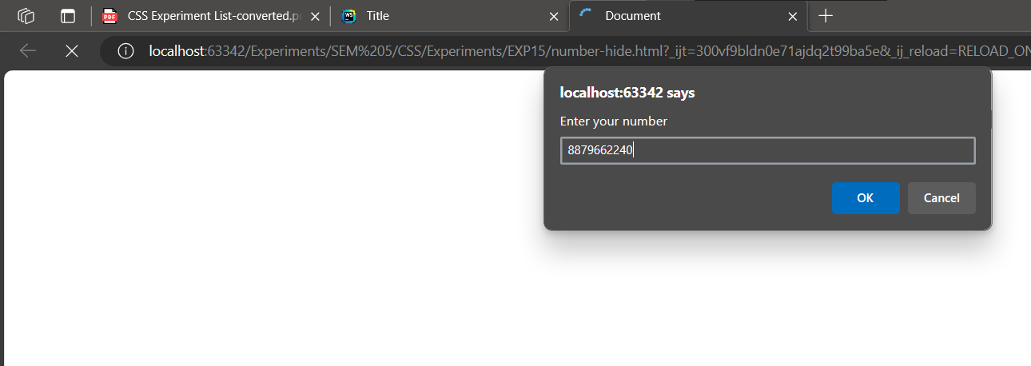

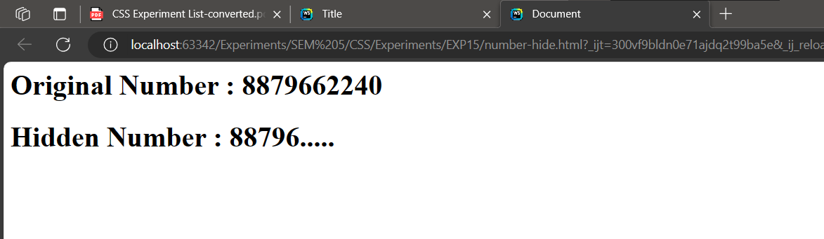

**3) Write a program to move a message along the body of the webpage**

**CODE:**

<!DOCTYPE html>  
<html lang="en">

<head>  
 <meta charset="UTF-8">  
 <title>Title</title>  
</head>

<body>  
<h1 id="msg">qarq90</h1>

<script>  
 const ***myText*** = ***document***.getElementById("msg");

let ***mySpace*** = 0;  
  
 function moveText(){  
 ***mySpace*** += 1;  
 ***myText***.style.marginLeft = ***mySpace*** + "px";  
 if (***mySpace*** > 500){  
 ***mySpace*** = 0;  
 }  
 setTimeout(moveText,5)  
 }  
 moveText();  
</script>

</body>  
</html>

**OUTPUT:**

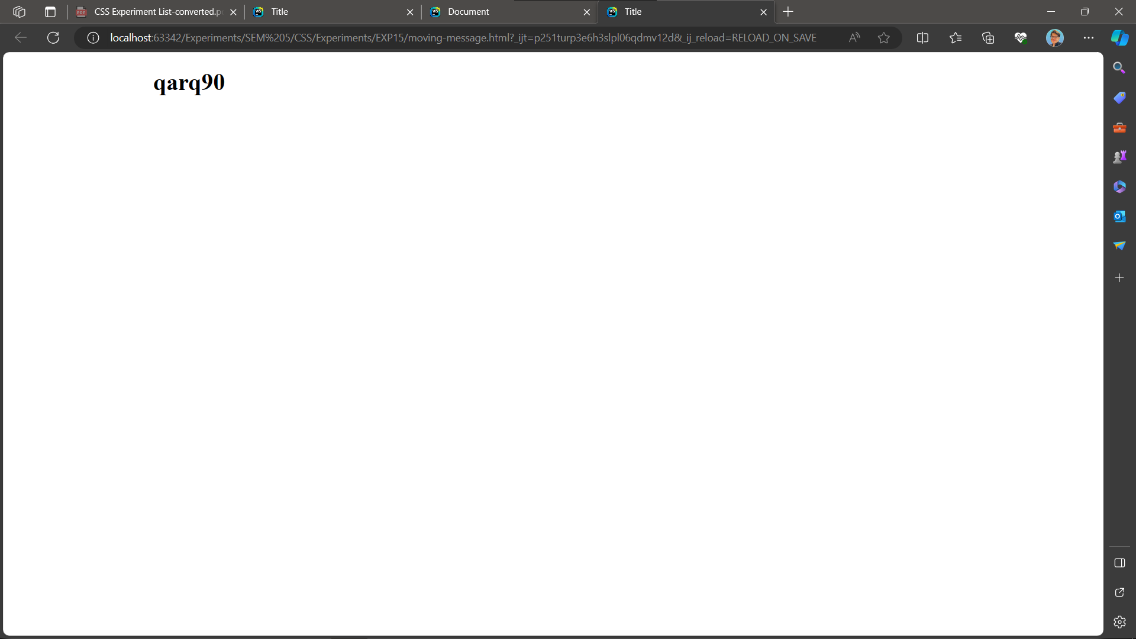

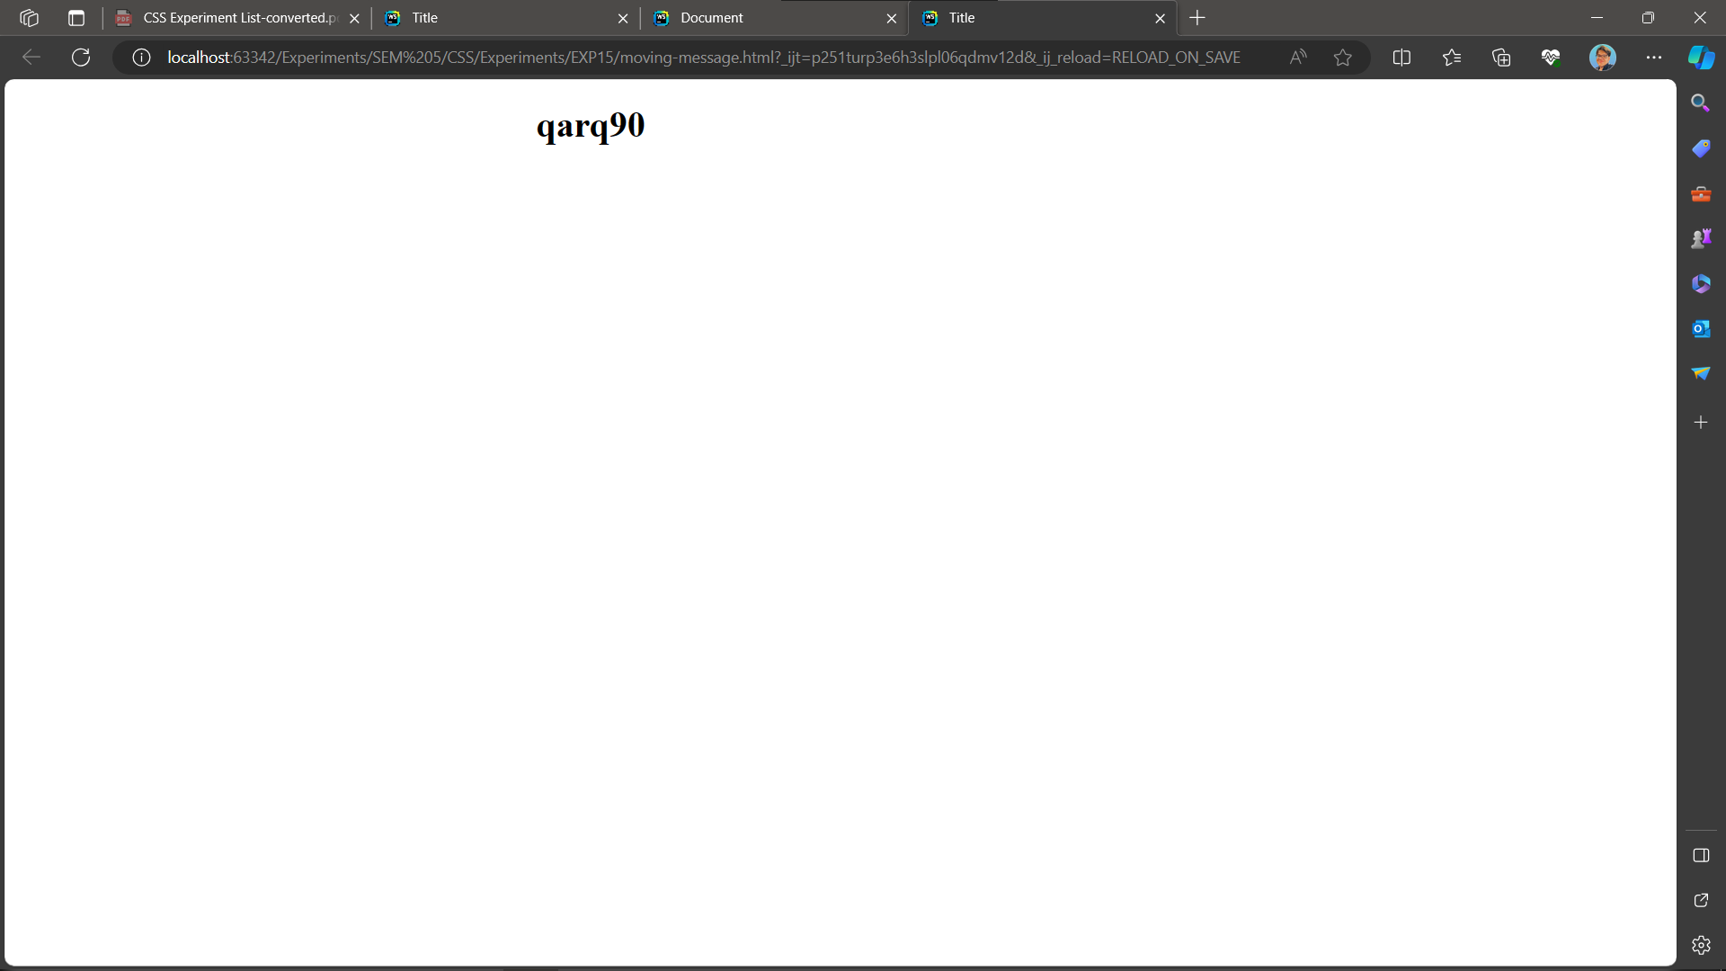

**4) Write a program to disable right click**

**CODE:**

<!DOCTYPE html>

<html>

<head>

<meta charset="UTF-8">

<title>Disable Right Click</title>

</head>

<body oncontextmenu="return false">

<h1>Right-click menu is disabled</h1>

</body>

</html>

**OUTPUT:**

